Position: | Consumer Sales Executive
Division: | Consumer Sales
Department: | Marketing
Reporting to | Senior Manager- Consumer Sales and Commercial Operations
Employment Type | Full time

Key Relationships | Internal  Marketing Team  Sales and Commercial Team  Operations  Infrastructure  Legal Department  Other internal stakeholders as relevant and appropriate  External  Ticketmaster  Official Licensees and Suppliers, as appropriate  Retailers  Key suppliers and commercial partners  Other stakeholders as relevant and appropriate

Values | Knowledge of and consistent demonstration of the Corporation’s IIQCAT values: Integrity, Innovation, Quality, Customer, Accountability, Teamwork.  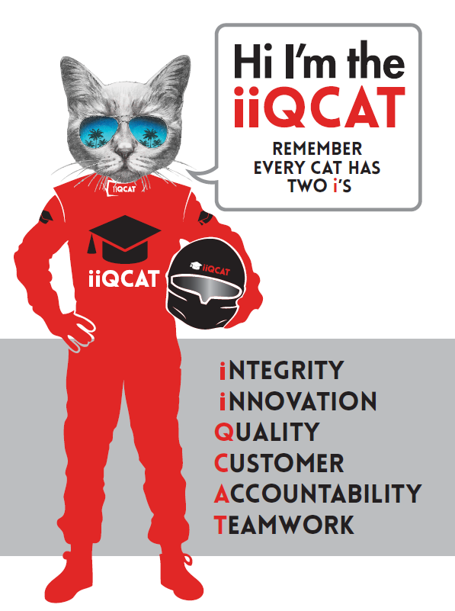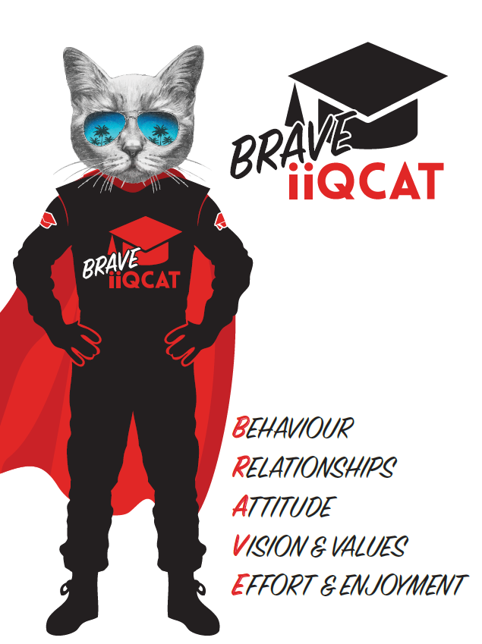
Corporation Objectives | To promote Melbourne and Victoria via the staging of two international sporting events - the Formula 1 Australian Grand Prix at Albert Park and the Australian MotoGP at Phillip Island.
Governed by | The Corporation is governed by the Australian Grands Prix Act 1994 (Vic).
Standards of behaviour | The Code of Conduct for Victorian Public Sector Employees governs the behaviour of all Corporation employees.
Human Rights | The Charter of Human Rights and Responsibilities Act 2006 is a Victorian law that sets out the basic rights, freedoms and responsibilities of all people in Victoria. The Charter requires the Corporation to act compatibly with human rights, and to consider human rights when developing policies, making laws, delivering services and making decisions.

Role Objectives | Reporting to the Senior Manager - Consumer Sales and Commercial Operations, the Consumer Sales Executive role will be responsible for evolving the membership strategy for both F1 and MotoGP and we are seeking a creative, strategic, well organised and talented individual with a fan-first mentality.  This role will oversee the development and implementation of strategies to not just ensure that current members renew their membership’s year on year, but also enacts campaigns to drive growth and engagement of new members.
Core Responsibilities | In a team of 4, the successful applicant will be able to facilitate ideas and a strategic plan to grow the membership programs for two world class events, the Formula 1 Australian Grand Prix and the Motorcycle Grand Prix.  - Develop and implement acquisition, lapsed member and renewal campaigns for Riders United and GP Advantage;  - Adopt best practice sports marketing strategies;  - Liaise with internal and external stakeholders to coordinate strategies to grow membership base;  - Identify new opportunities and strategies to grow the membership base;  - Management of all membership fulfilment;  - Manage member data and customer feedback process;  - Manage membership research projects and  - Manage all membership fulfilment activities during both events  Governance  Adhere to Corporation policies, procedures, and directives regarding standards of workplace behaviour in completing job duties and assignments.  Conducting every aspect of work in a trustworthy, reliable and transparent manner, and maintaining the highest ethical standards.  Customer Service  Putting internal and external customers first, building strong relationships and ensuring that the approach is responsive to the needs of the internal/external customer.  Encouraging openness and trust by sharing information widely, listening, welcoming constructive challenge and encouraging free dialogue.  Continuous Improvement  Taking initiative to improve operations/services/products and systems so that they are consistent with the Corporation’s strategic direction and values; incorporating innovation and experimentation into daily work.  Health and Safety  To assist the Corporation in meeting its health and safety obligations you will be required to:  - Actively participate in the reporting of hazards, incidents and near misses.  - Take corrective action to address or mitigate any risks or hazardous situations throughout the course of your work.  - Take reasonable care for your own health and safety, and for the health and safety of others.  - Adhere to the Corporation’s various policies, procedures, work practices and standard operating procedures.  - Perform your role in accordance with any specific responsibilities as outlined in the Corporation’s safety management system.  To enable the Corporation to meet its obligations for providing a healthy and safe working environment for you, you must inform your manager of any issues which may impact your ability to safely perform your role.  Environmental Considerations  Cooperate with the Corporation regarding caring for the environment, by acting in a sustainable way and minimising environmental impact by adhering to the Corporation’s policies, procedures and work practices.

Person Specification

Qualifications and Experience | About You:  - 2+ years of marketing experience (preferable)  - 2 - 3 years customer management experience  - Thorough understanding of the membership sector and what it takes to make an organisation successful in that area  - Highly developed customer service and relationship management skills  - Effective self-management, including the ability to prioritise, meet deadlines and time management  - Strong understanding of CRM applications  - Strong knowledge of ticketing systems  - Flexibility of working hours (to suit the varying time schedule and seasonal priorities)  - Hold a valid Driver's Licence  - The successful candidate will require a valid Victorian Working with Children Check

Relevant Traits and Characteristics | Customer Service  - Demonstrated achievement in and enthusiasm for the provision of quality customer service  - Immediately respond to customers’ needs or concerns to ensure the quality of service meets agreed standards  Teamwork, Adaptability and Resilience  - Demonstrated commitment to teamwork and the maintenance of a supportive work environment  - Ability to work effectively as part of a team in a fast-changing environment  - Keeping calm by demonstrating a capacity to positively deal with unanticipated problems and changing circumstances  Interpersonal, Verbal and Written Communication  - Well-developed written communication ability  - Strong interpersonal and communication skills  - An ability to liaise, negotiate and constructively provide and accept feedback from staff at all levels  Organisation and Planning  - Organisational and planning skills in managing a personal workload in a busy environment with conflicting demands  - Ability to meet deadlines  Technology  - Experience in the use of Microsoft desktop products such as Word, Excel, Outlook and PowerPoint  - Experience in information management systems, including internet and on-line environments  Continuous Learning and Professional Development  - Demonstrated commitment to continual professional and personal development

